 *INTERNATIONAL ISLAMIC UNIVERSITY CHITTAGONG*

*DEPARTMRNT OF COMPUTER SCIENCE & ENGINEERING*

**Project on :** Courier Management System

**Course code :** CSE-2424

**Course title :** Database Management Systems Lab

***Submitted by-***

**Name :** Nafisa Nawar

**ID :** C221222

**Semester :** 4th

**Section :** 4AF

**Date of submission:** 17/11/2023

***Submitted to-***

**Dr.Mohammad Aman Ullah**

*Associate Professor*

*Department of CSE, IIUC*

* **What is courier?**
* A courier is a person or organization that delivers a message, package or letter from one place or person to another place or person.
* **What does mean courier management system?**
* A courier delivery management system, or CMS, is business software that simplifies courier management and routing.
* Courier management refers to the organization and coordination of last-mile -delivery  operations. It involves scheduling deliveries, assigning couriers, managing operations, optimizing routes, and controlling fuel and expense costs. A courier management system, also known as courier software, manages the transportation of shipments from the warehouse to the customer. It automates the many operations involved in delivery businesses, such as real-time tracking.
* **Advantage of courier management system:**
* They help transport businesses manage the dispatch of packages. With the rise of next-day and same-day delivery demands, a reliable courier management system is a must-have
* There are three main objectives of courier management: Deliver products to customers. Support the couriers delivering those products. Ensure that customers have a great buying experience, so they come back for more.

***CONCEPTUAL ER-DIAGRAM***

***NORMALIZED ER-DIAGRAM***

***DATABASE SCHEMA***

**1.ADMIN** (A_ID, A_NAME, MOBILE_NO, EMAIL,ADDRESS)

**2.COURIER** (CO_ID, CONTACT_NUM, CO_NAME)

**3.CUSTOMER** (C_ID,C_NAME,C_EMAIL,C_MOBILE_NO,C_ADDRESS)

**4.ITEM** (ITEM_ID,ITEM_NAME,ITEM_CODE,ITEM_WEIGHT)

**5.PARCEL** (P_ID,AMOUNT,PRICE,DELIVERY_DATE)

**6.ROUTE** (R_ID,ORIGIN,TIME_OF_ARRIVAL,LOCATION,DISPATCH_CENTER)

***DDL STATEMENT***

* **ADMIN TABLE**

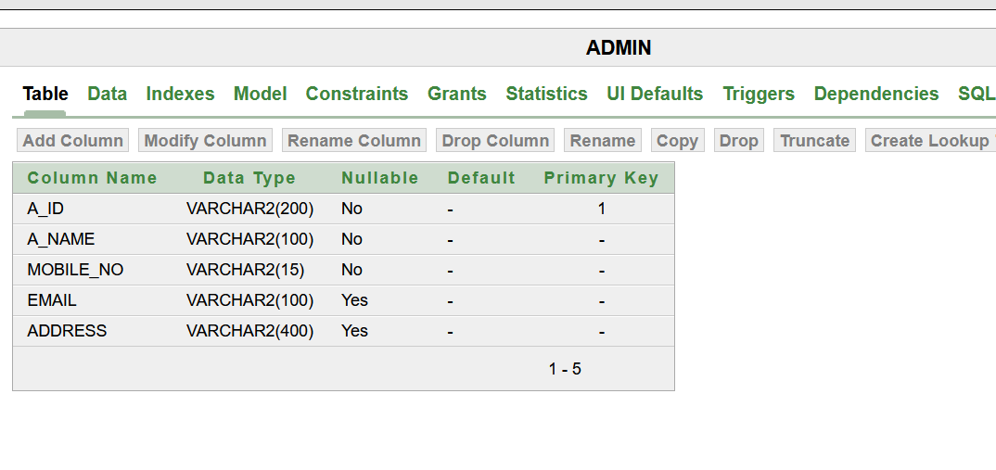

**SQL**

CREATE TABLE "ADMIN"

( "A_ID" VARCHAR2(200) NOT NULL ENABLE,

"A_NAME" VARCHAR2(100) NOT NULL ENABLE,

"MOBILE_NO" VARCHAR2(15) NOT NULL ENABLE,

"EMAIL" VARCHAR2(100),

"ADDRESS" VARCHAR2(400),

CONSTRAINT "ADMIN_PK" PRIMARY KEY ("A_ID") ENABLE

)

/

* 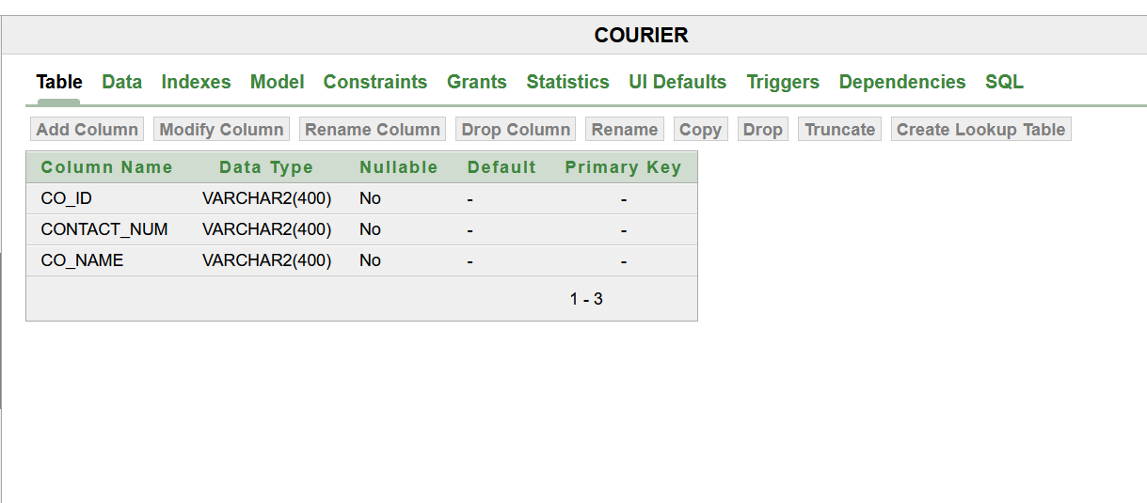**COURIER TABLE**

**SQL**

CREATE TABLE "COURIER"

( "CO_ID" VARCHAR2(400) NOT NULL ENABLE,

"CONTACT_NUM" VARCHAR2(400) NOT NULL ENABLE,

"CO_NAME" VARCHAR2(400) NOT NULL ENABLE

)

**/**

* **CUSTOMER TABLE**

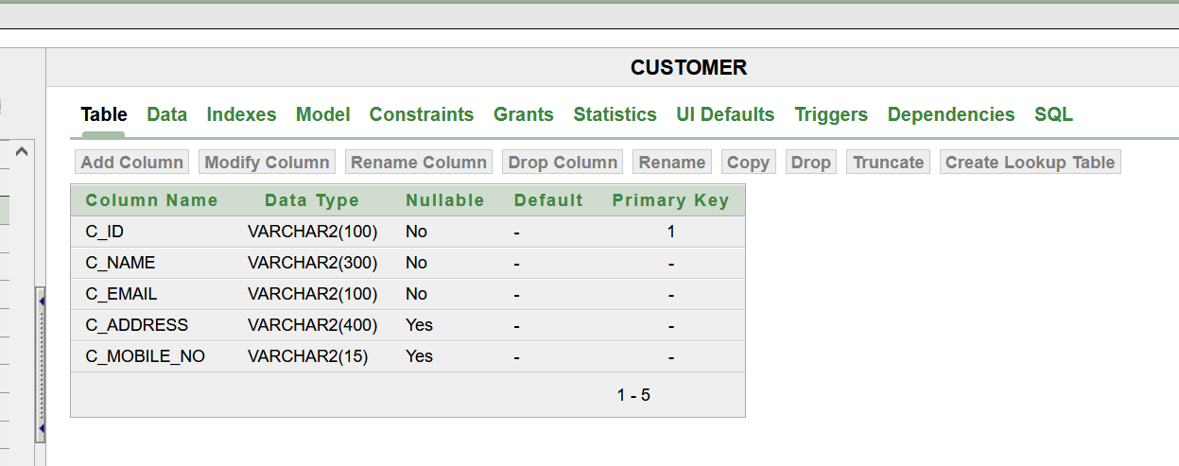

**SQL**

CREATE TABLE "CUSTOMER"

( "C_ID" VARCHAR2(100) NOT NULL ENABLE,

"C_NAME" VARCHAR2(300) NOT NULL ENABLE,

"C_EMAIL" VARCHAR2(100) NOT NULL ENABLE,

"C_ADDRESS" VARCHAR2(400),

"C_MOBILE_NO" VARCHAR2(15),

CONSTRAINT "CUSTOMER_PK" PRIMARY KEY ("C_ID") ENABLE

)

/

* **ITEM TABLE**

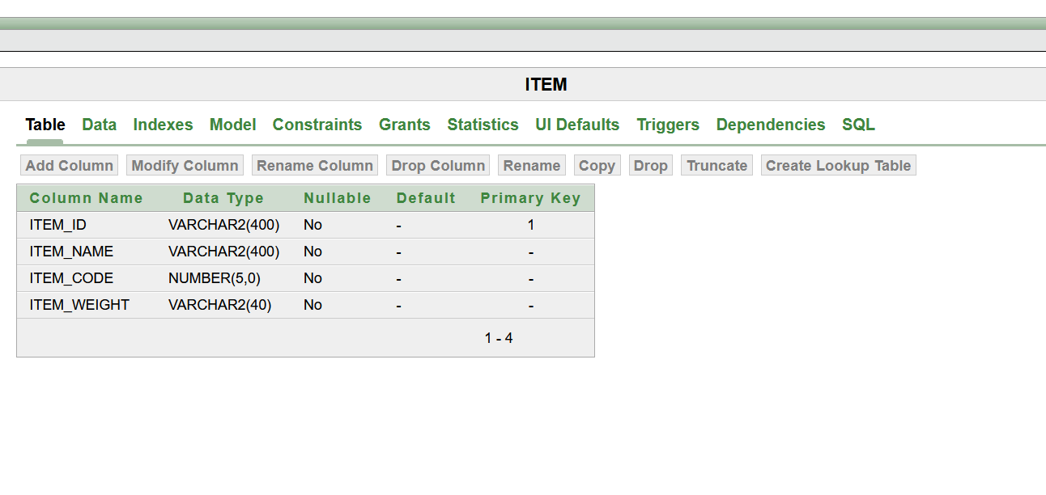

**SQL**

CREATE TABLE "ITEM"

( "ITEM_ID" VARCHAR2(400) NOT NULL ENABLE,

"ITEM_NAME" VARCHAR2(400) NOT NULL ENABLE,

"ITEM_CODE" NUMBER(5,0) NOT NULL ENABLE,

"ITEM_WEIGHT" VARCHAR2(40) NOT NULL ENABLE,

CONSTRAINT "ITEM_PK" PRIMARY KEY ("ITEM_ID") ENABLE,

CONSTRAINT "ITEM_CK1" CHECK (Item_Weight<'50kg') ENABLE

)

/

* **PARCEL TABLE**

|  |
| --- |
|  |

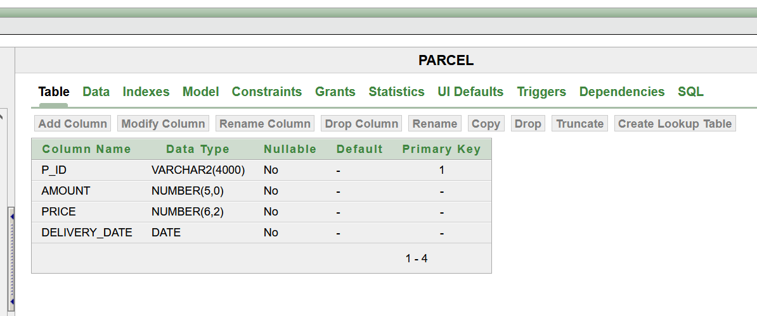

**SQL**

CREATE TABLE "PARCEL"

( "P_ID" VARCHAR2(4000) NOT NULL ENABLE,

"AMOUNT" NUMBER(5,0) NOT NULL ENABLE,

"PRICE" NUMBER(6,2) NOT NULL ENABLE,

"DELIVERY_DATE" DATE NOT NULL ENABLE,

CONSTRAINT "PARCEL_PK" PRIMARY KEY ("P_ID") ENABLE

)

/

* **ROUTE TABLE**

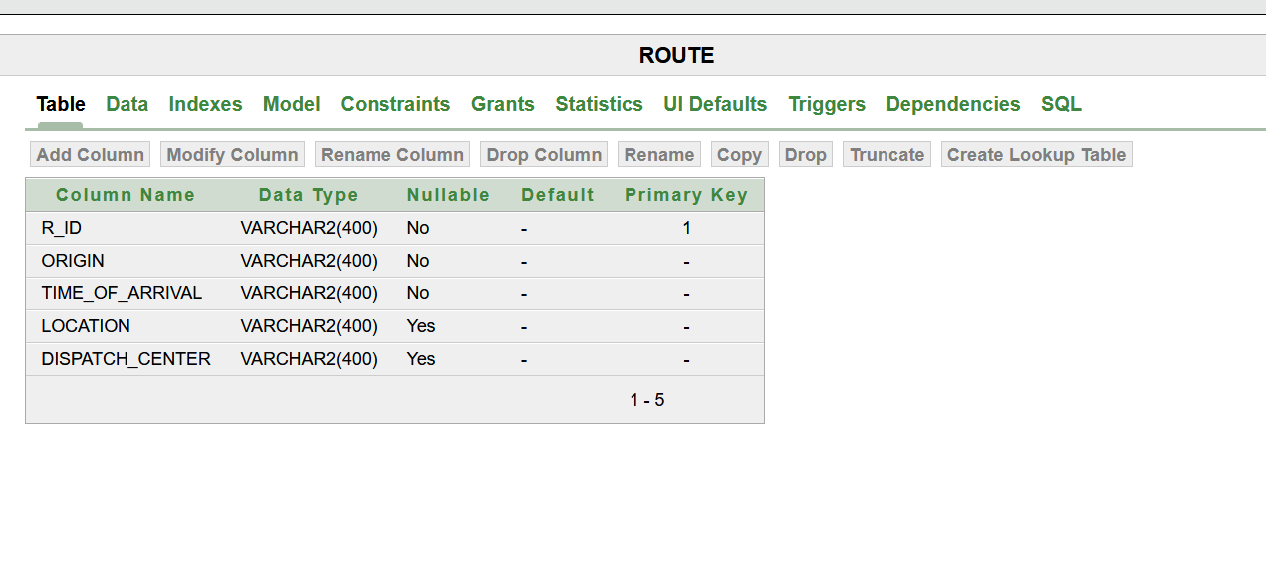

**SQL**

CREATE TABLE "ROUTE"

( "R_ID" VARCHAR2(400) NOT NULL ENABLE,

"ORIGIN" VARCHAR2(400) NOT NULL ENABLE,

"TIME_OF_ARRIVAL" VARCHAR2(400) NOT NULL ENABLE,

"LOCATION" VARCHAR2(400),

"DISPATCH_CENTER" VARCHAR2(400),

CONSTRAINT "ROUTE_PK" PRIMARY KEY ("R_ID") ENABLE

)

/

***DML STATEMENT***

* **DATA IN ADMIN TABLE**

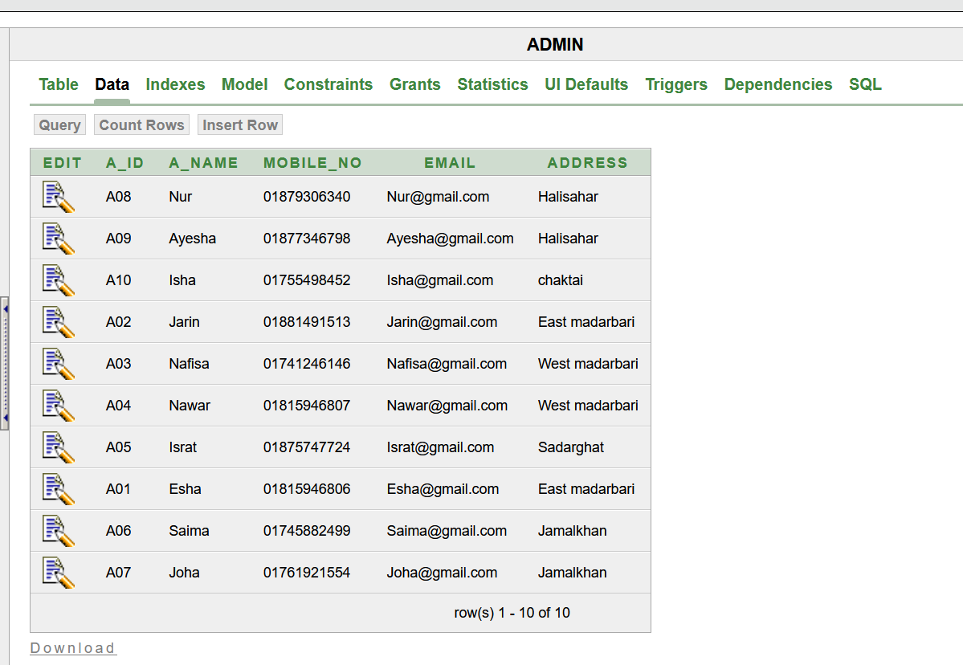

* **DATA IN COURIER TABLE**

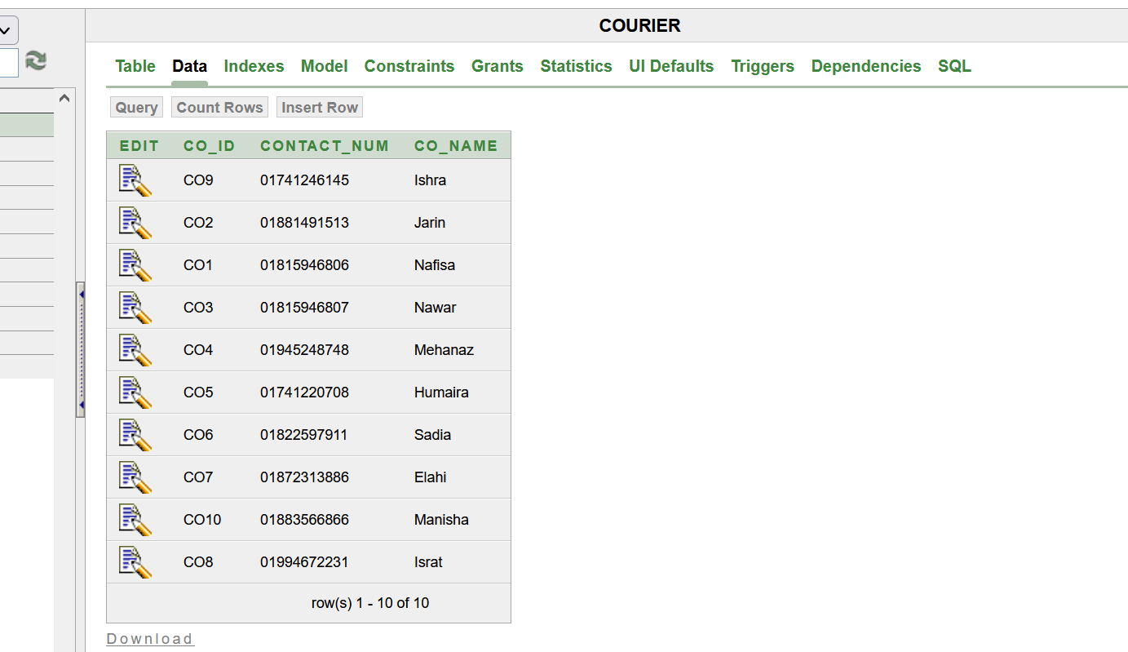

* **DATA IN CUSTOMER TABLE**

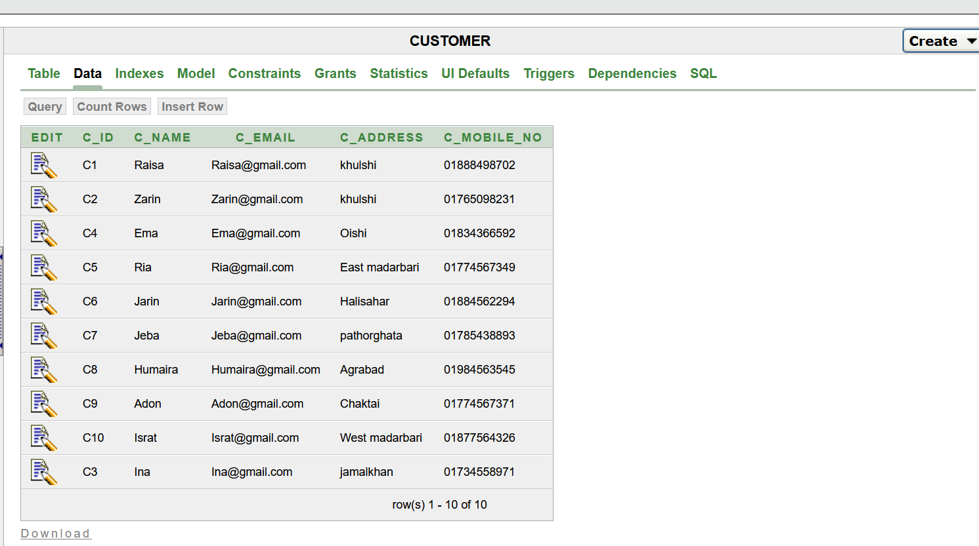

* **DATA IN ITEM TABLE**

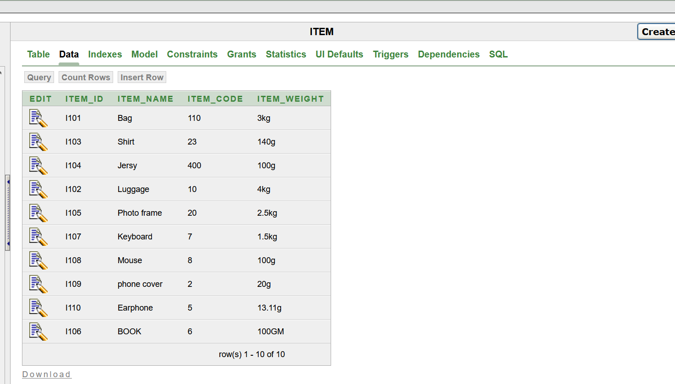

* **DATA IN PARCEL TABLE**

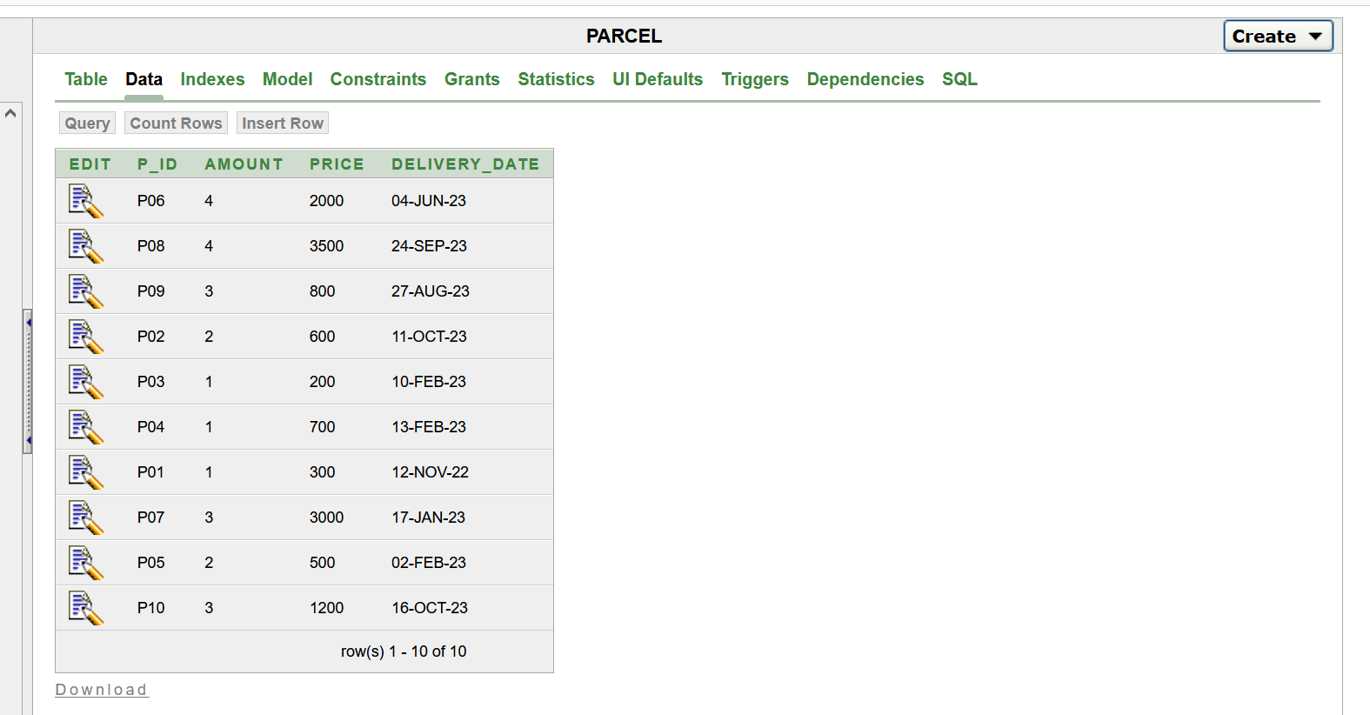

* **DATA IN ROUTE TABLE**

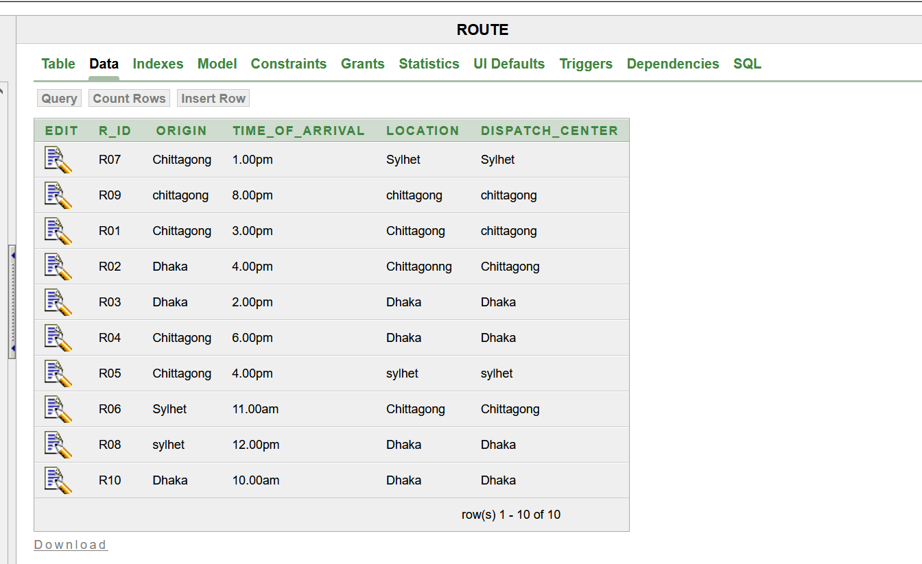

3.Find those customer who live in Bangladesh

SELECT*

FROM CUSTOMER

WHERE C_ADDRESS='Chittagong';

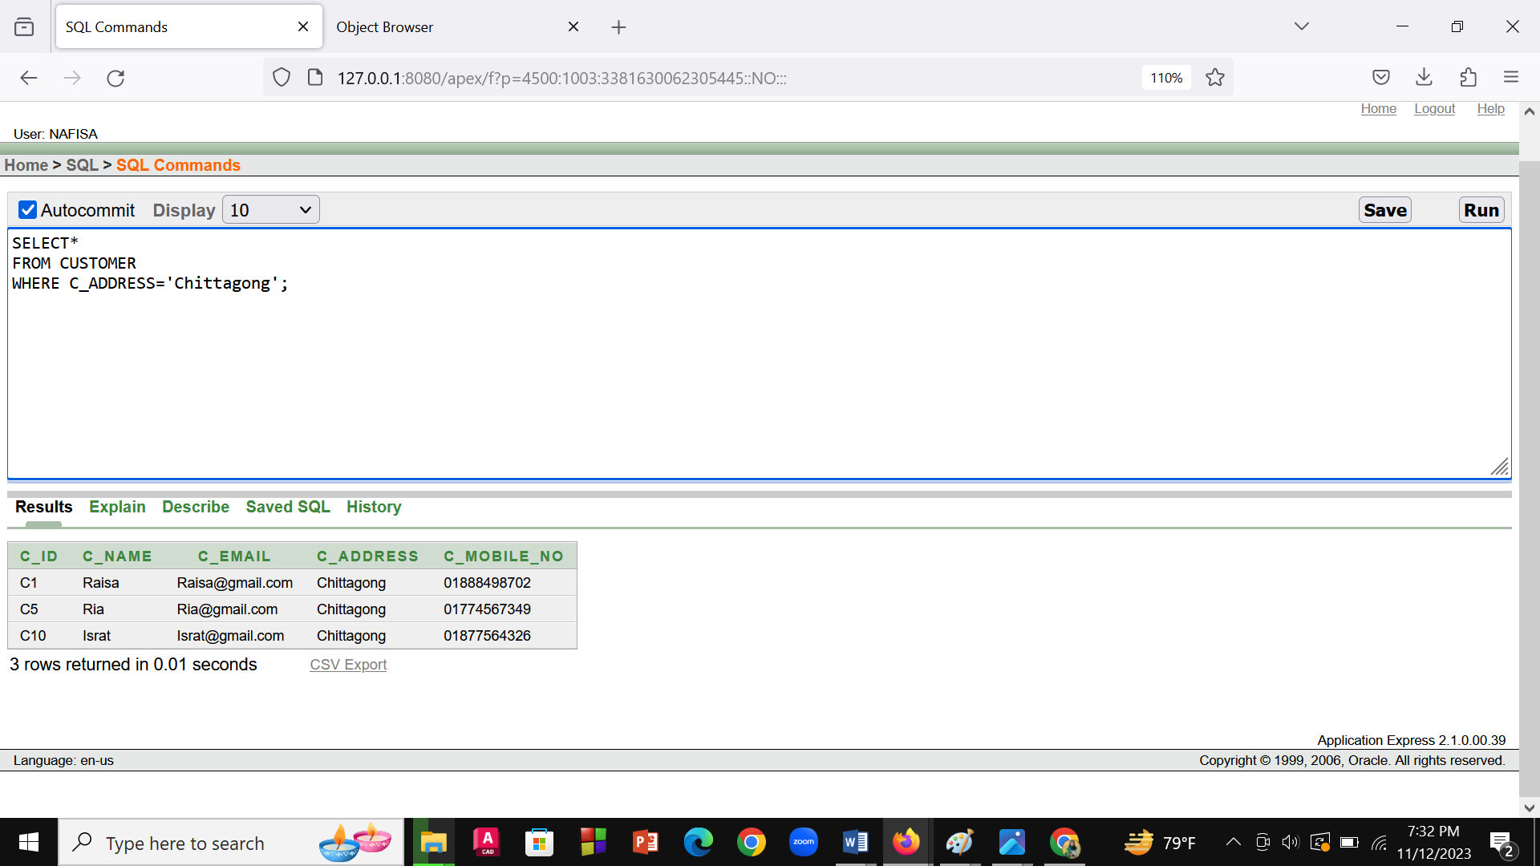

**4.** Find that customer whose id is C3, C7, C10

SELECT *

FROM CUSTOMER

WHERE C_ID IN ('C7', 'C3', 'C10') ;

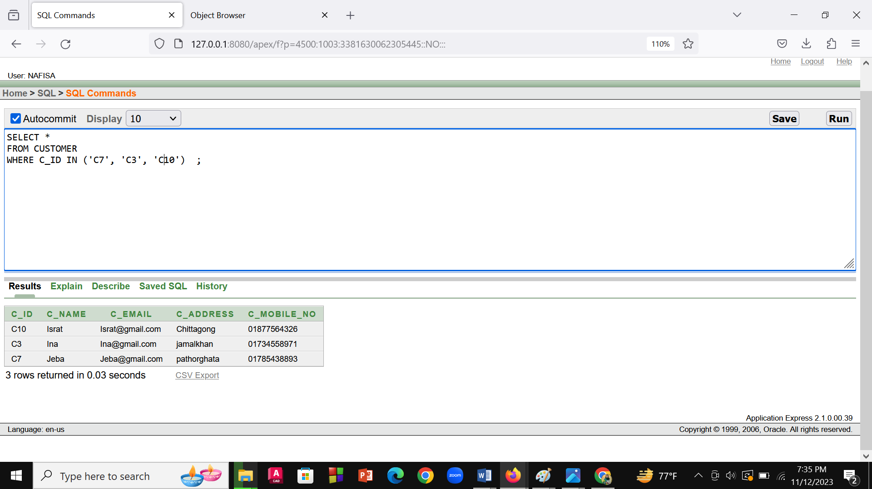

*5.* Find that item which weight between 10g to 4000kg

SELECT *

FROM ITEM

WHERE ITEM_WEIGHT BETWEEN '10g' and '4000g';

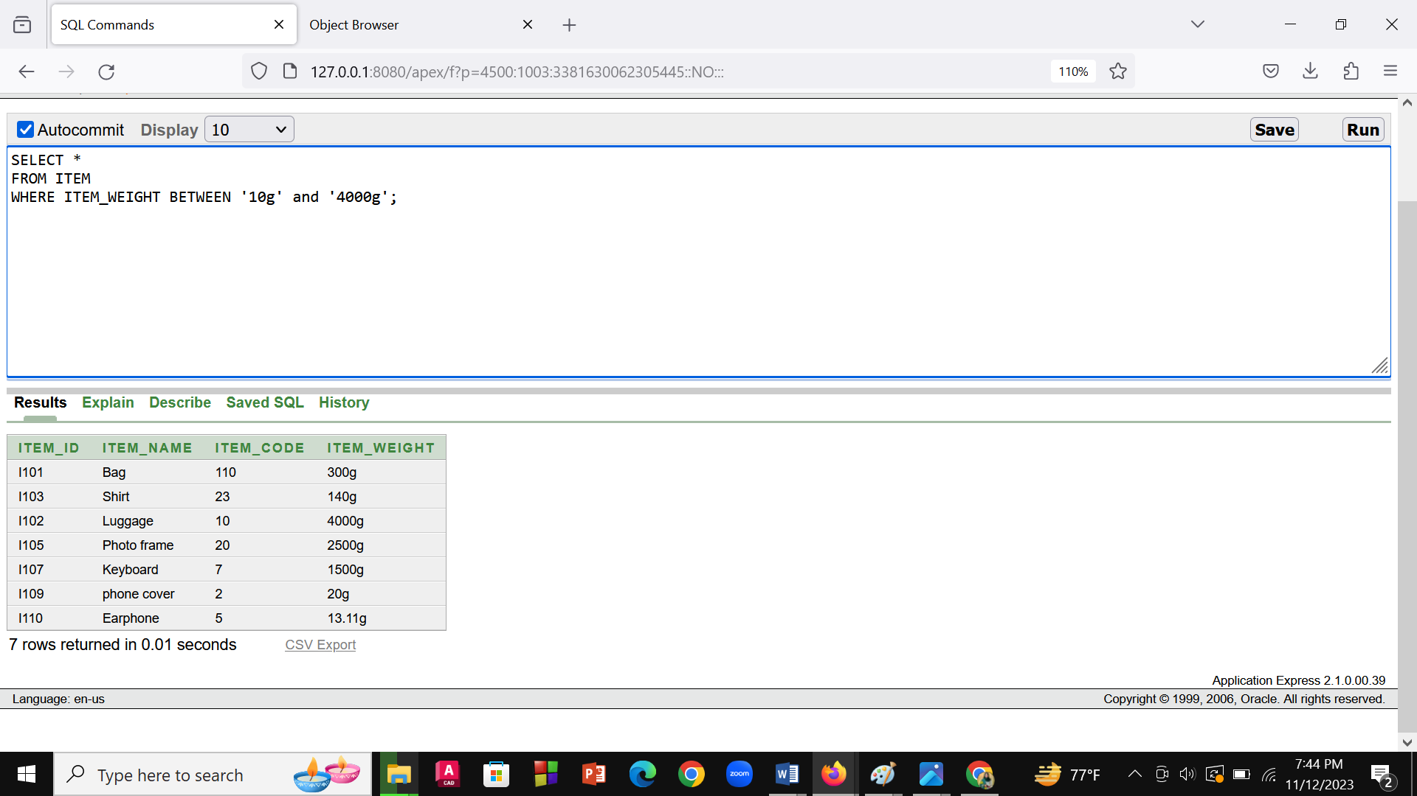

*6.* *Find that name of items which strings ‘er’.*

*SELECT \**

*FROM ITEM*

*WHERE ITEM_NAME LIKE '%er%';*

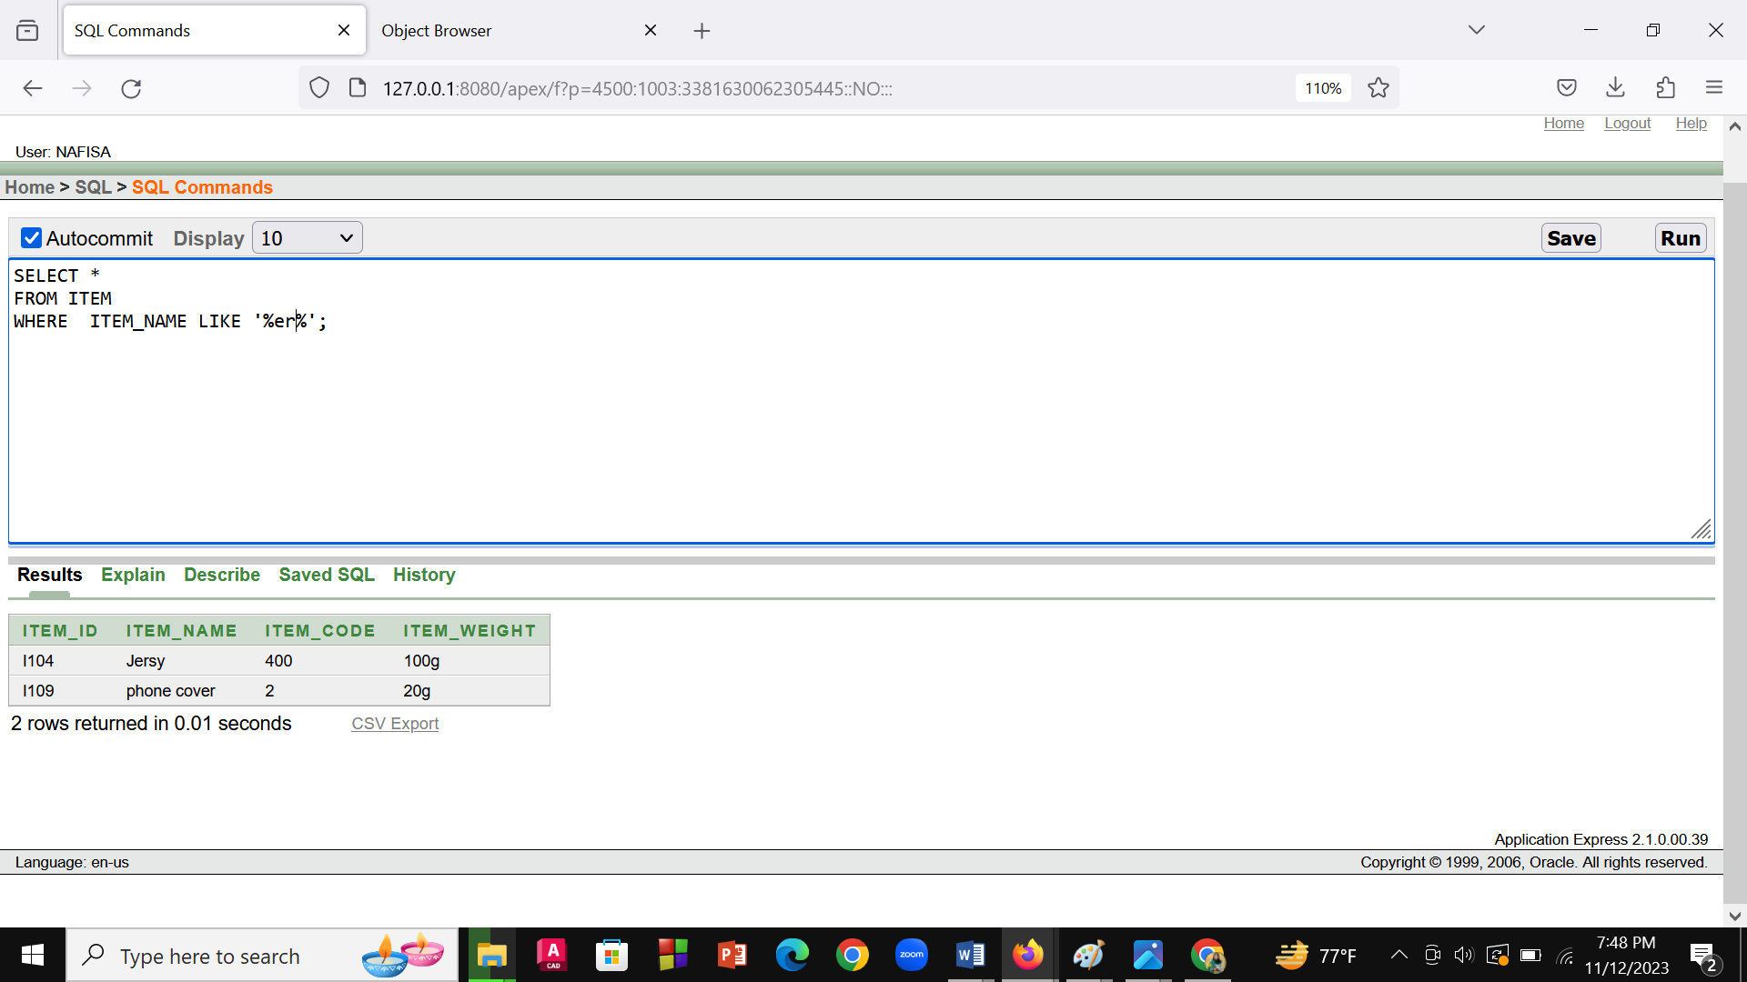

*7.* Find those parcel which location and dispatch center is in same district Chittagong.

*SELECT\**

*FROM ROUTE*

*WHERE LOCATION='Chittagong' and DISPATCH_CENTER='Chittagong';*

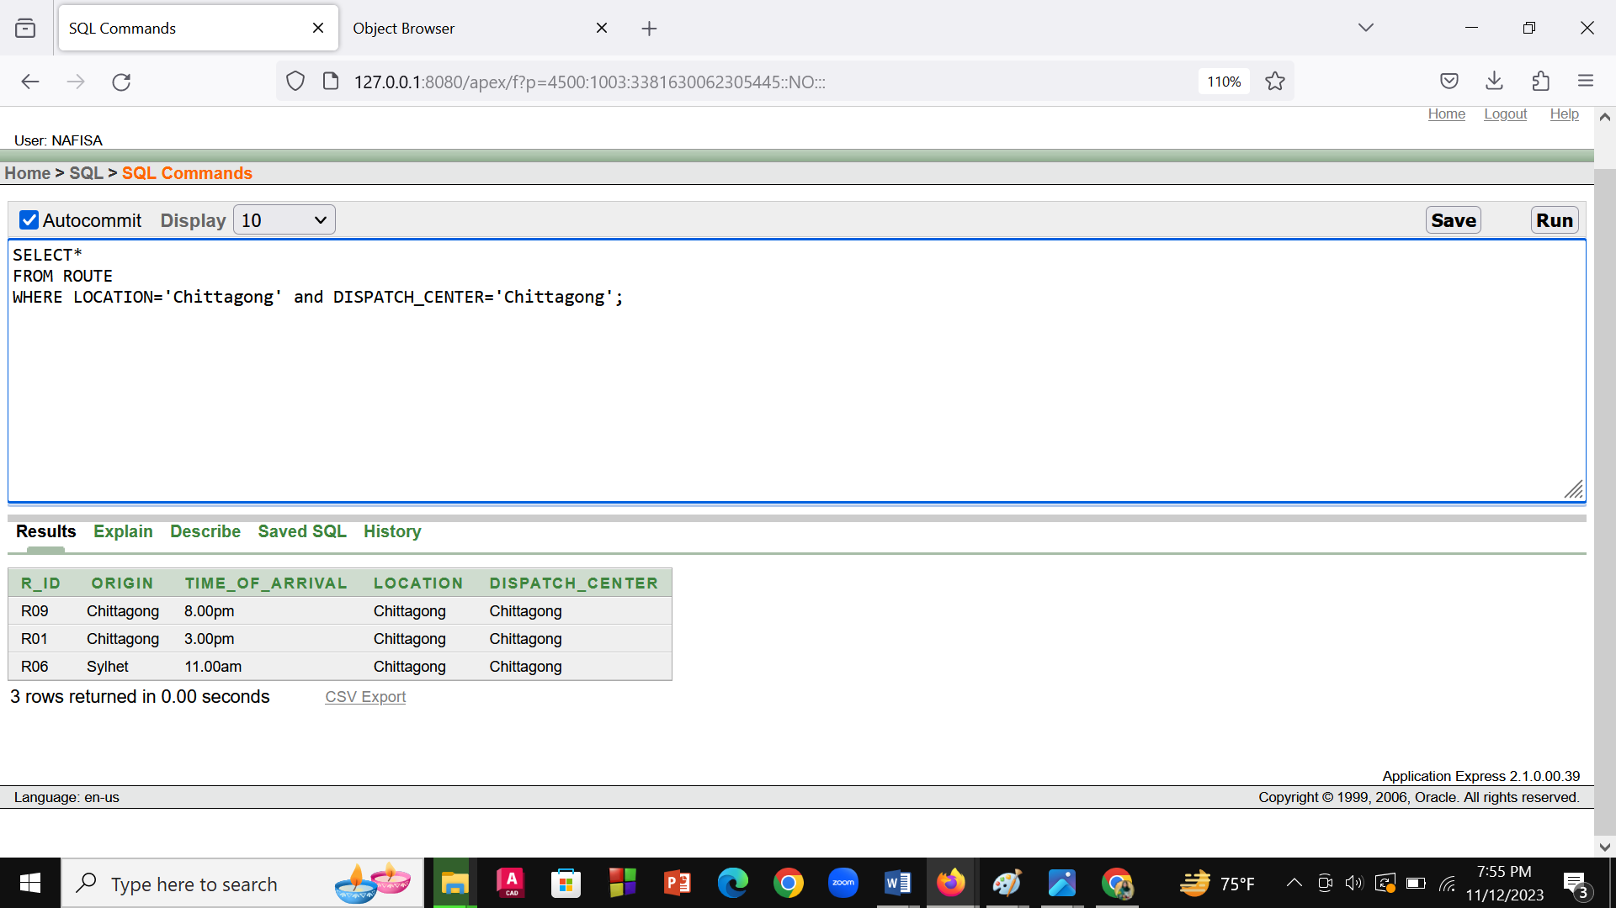

*8.* Find Total admin from the table Admin.

*SELECT COUNT (DISTINCT A_ID)*

*FROM ADMIN;*

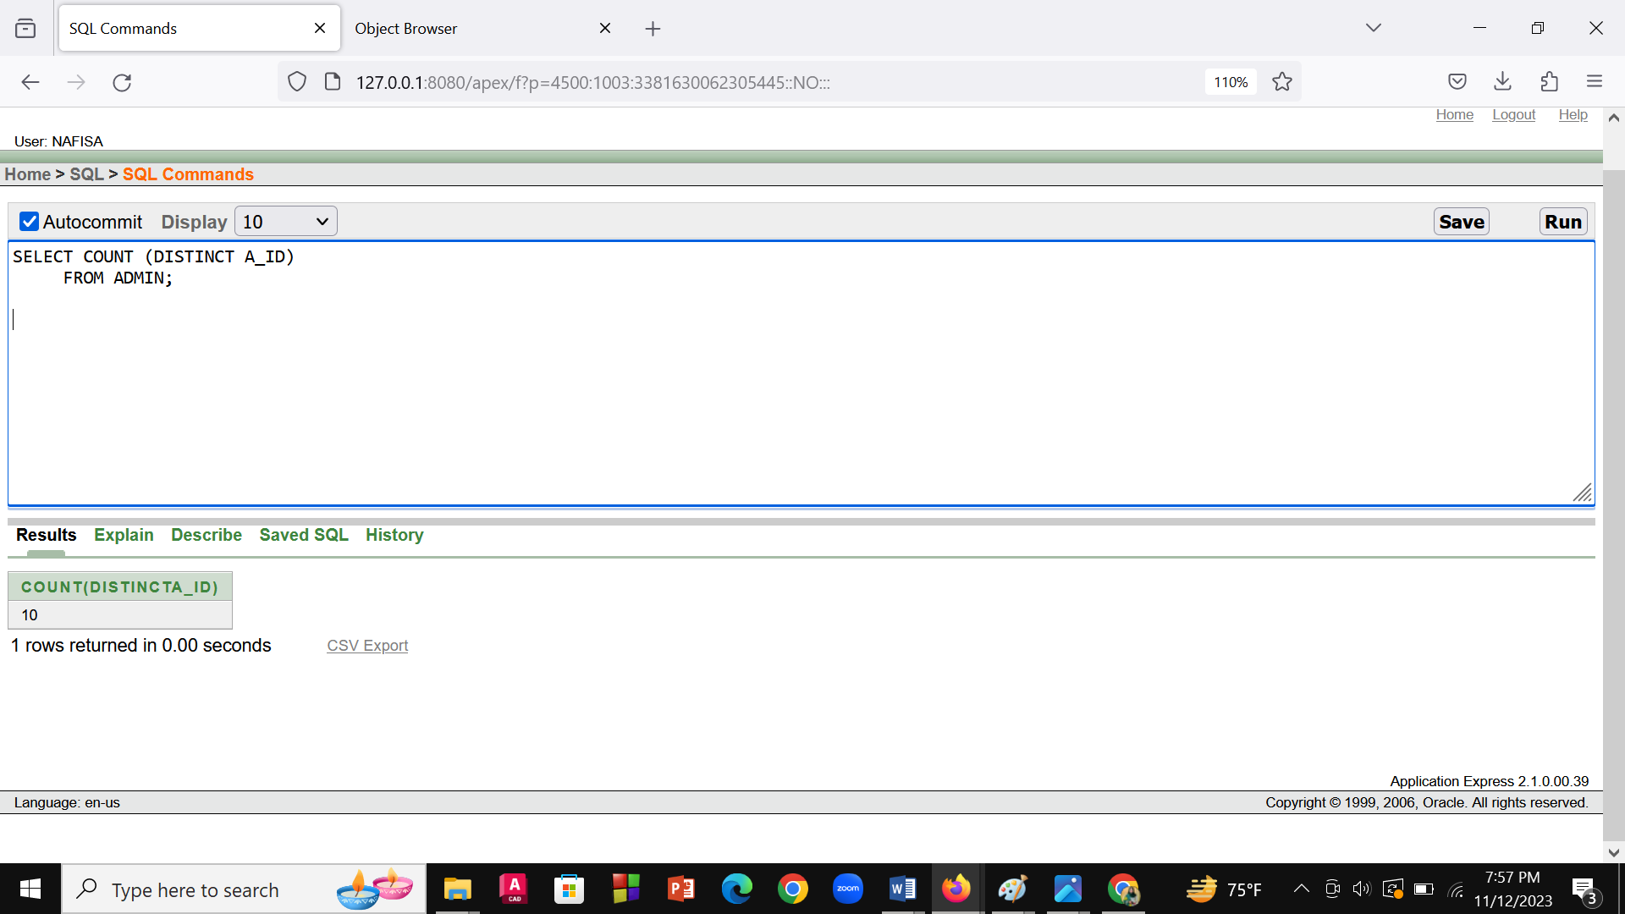

**9.** Find the length of customer name and contains “a” from customer table

**SELECT C_ID, C_NAME,**

**LENGTH (C_NAME), INSTR (C_NAME, 'a') "Contains 'a'?"**

**FROM CUSTOMER**

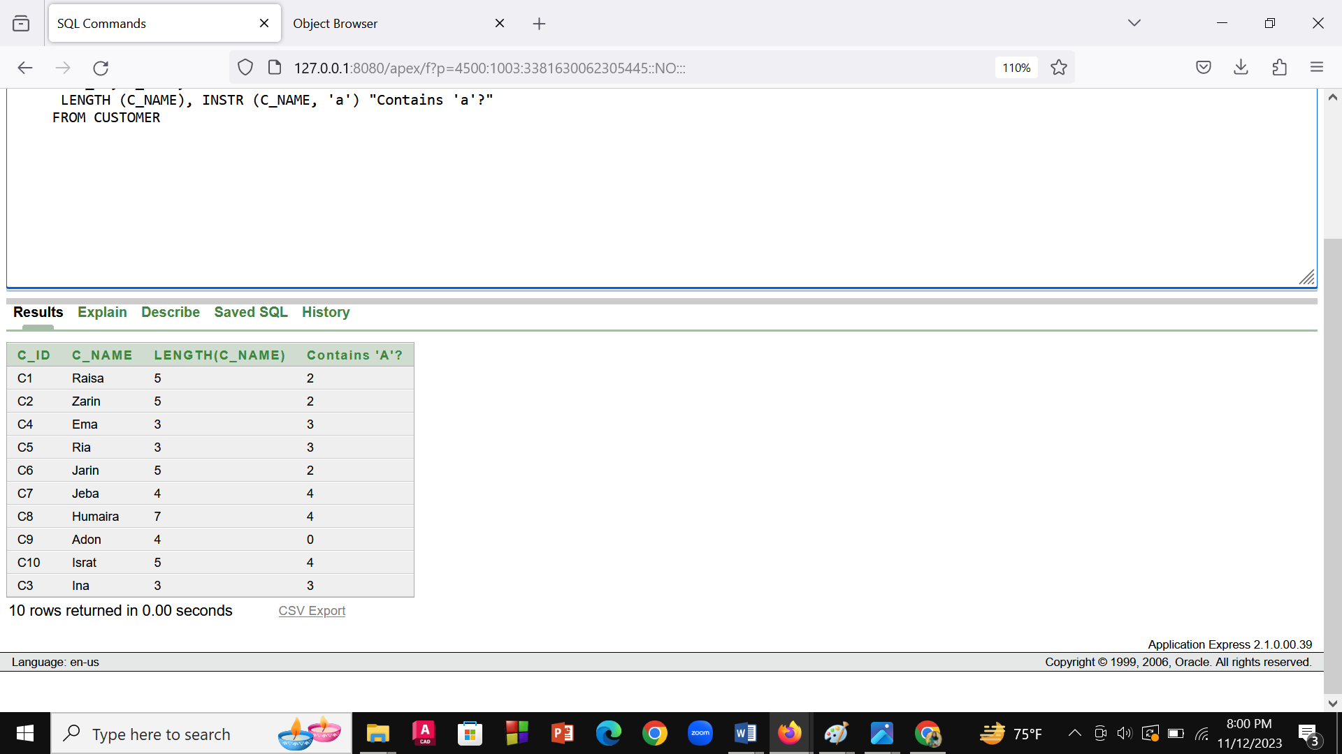

**10.** Find those parcels location which not belongs to Dhaka and Sylhet from route table.

*SELECT R_ID, LOCATION*

*FROM ROUTE*

*WHERE LOCATION NOT IN ('Dhaka', 'Sylhet');*

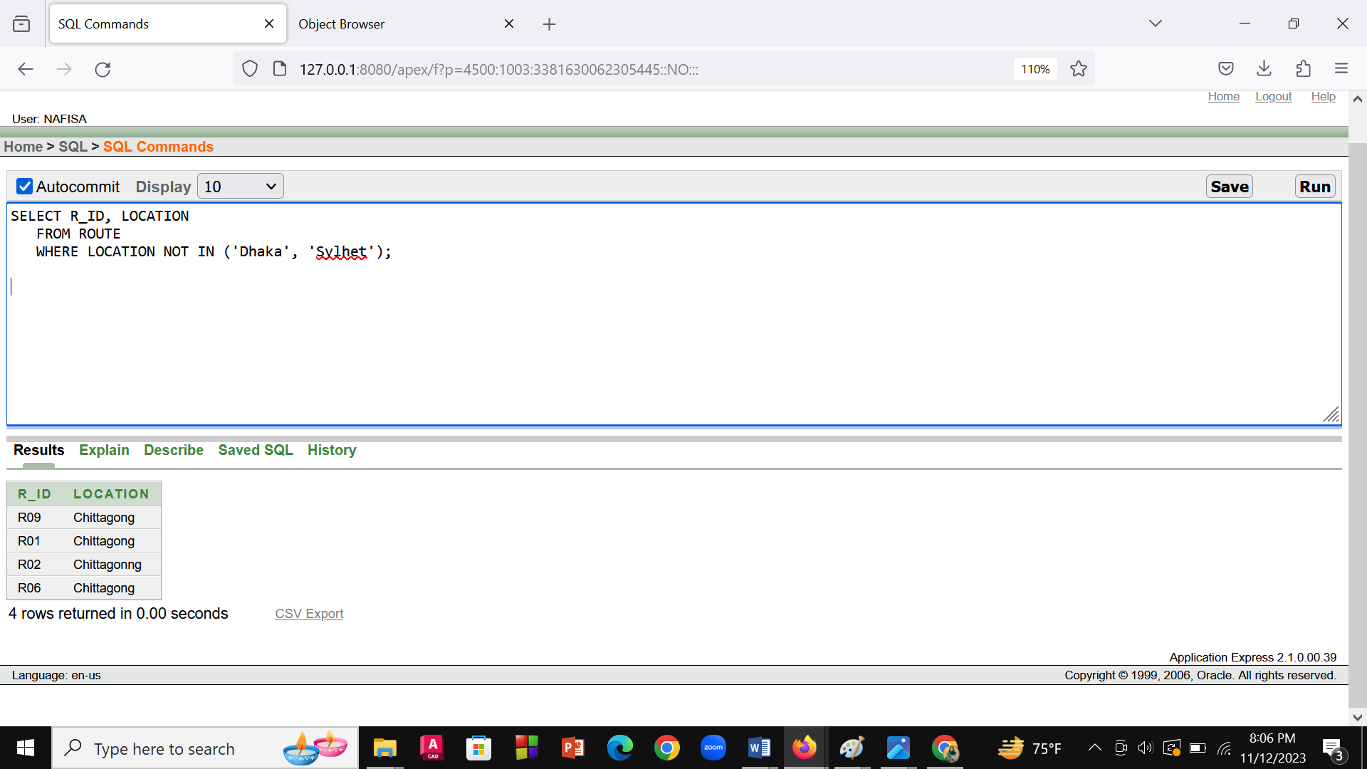

**Searching all data from multiple table :**

Query-1

Show the all data of table Customer and Parcel using full outer join

**SELECT\***

**From CUSTOMER NATURAL JOIN C_BILL NATURAL JOIN PARCEL**

**WHERE PRICE <700;**

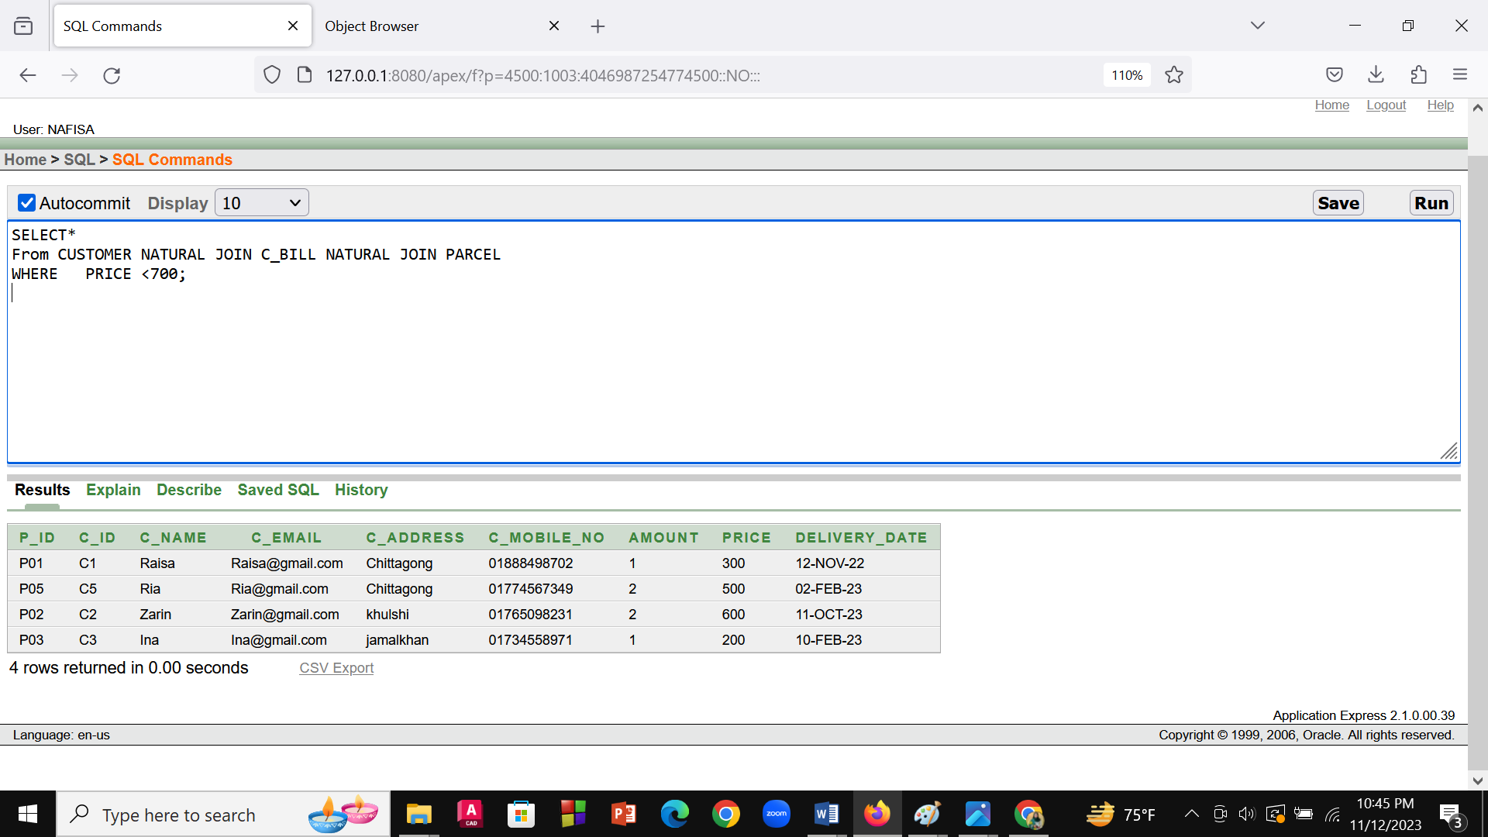

**2.** Show the all data of table C_BILL and Manage using full outer join.

SELECT B.C_ID, B.P_ID, M.C_ID, M.P_ID, M.ITEM_ID

FROM C_BILL B FULL OUTER join MANAGE M

ON (B.C_ID=M.P_ID);

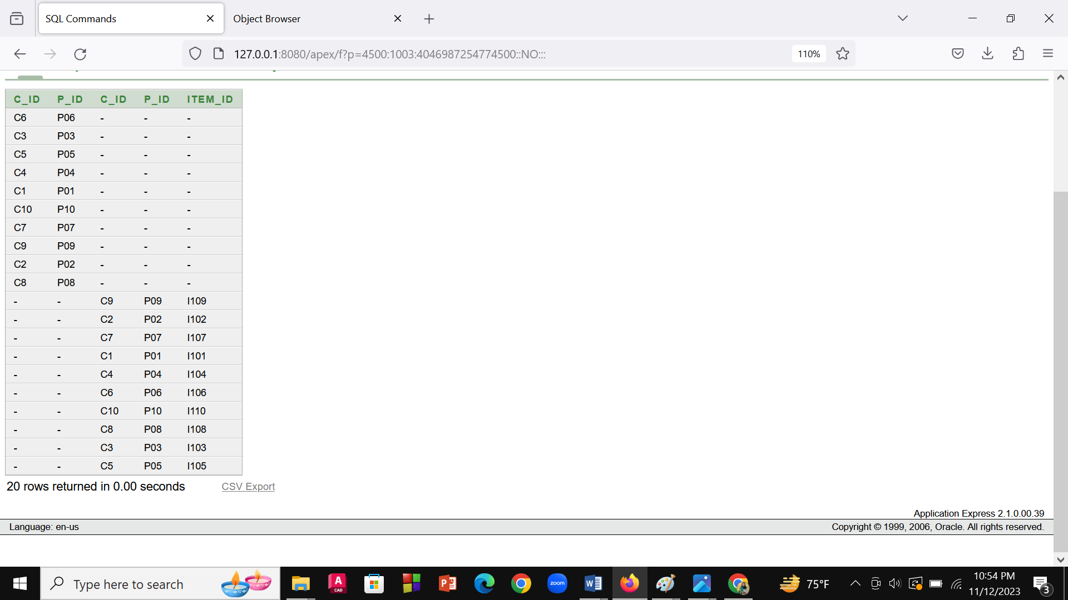

Query-3

Show the CUSTOMER who paid amount less than 3500 TK.

*SELECT C.C_ID, C.C_NAME, P.P_ID,P.AMOUNT, P.PRICE*

*FROM CUSTOMER C LEFT OUTER join PARCEL P*

*ON (C.C_ID=P.P_ID)*

*WHERE PRICE < 350;*

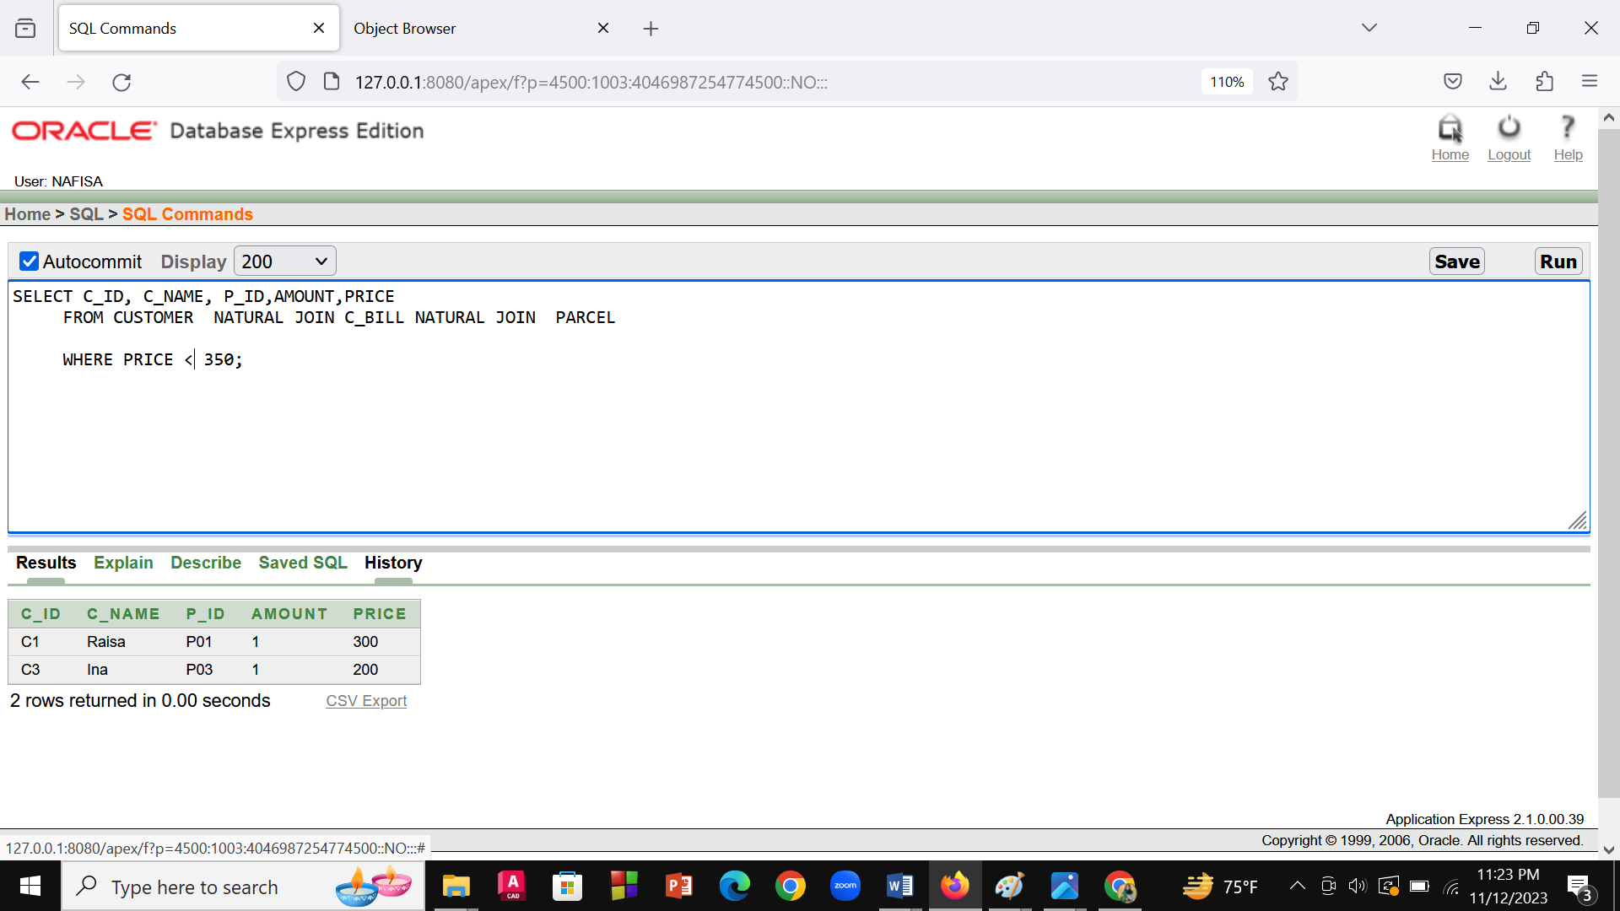

**SUB QUERY**

**1.Give information of all admin whose admin name is same as Jarin.**

SELECT *

FROM ADMIN

WHERE A_NAME=(SELECT A_NAME

FROM ADMIN

WHERE A_NAME='Jarin')

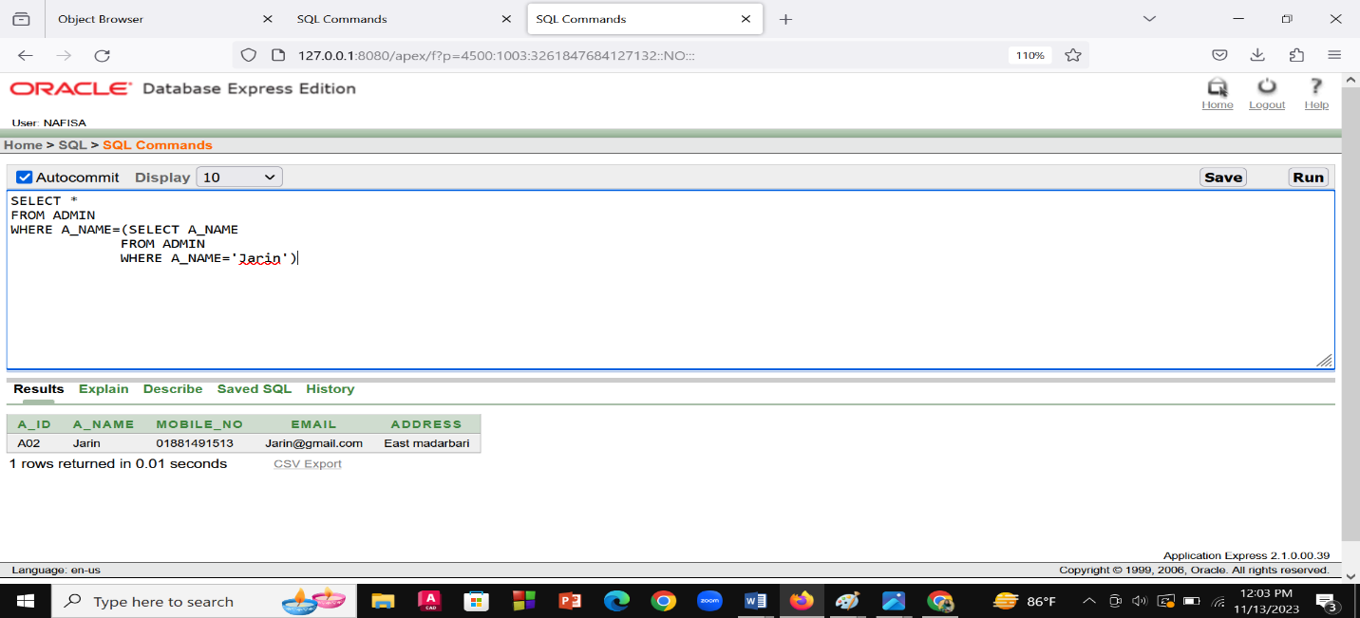

2.Show the customer details whose customer address is not ‘Dhaka’.

SELECT *

FROM CUSTOMER

WHERE C_ADDRESS NOT IN (SELECT C_ADDRESS

FROM CUSTOMER

WHERE C_ADDRESS='Dhaka')

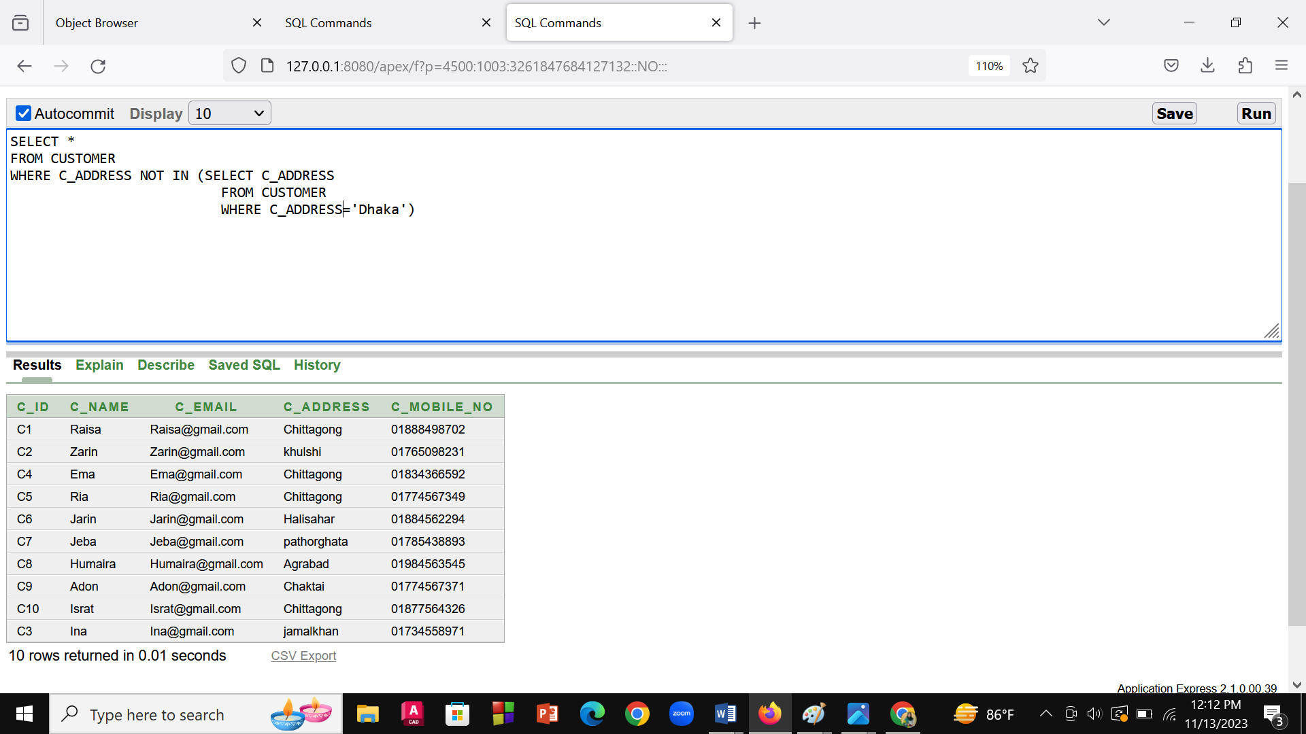

3.Show the courier name of courier id ‘CO1’.

SELECT CO_NAME,CO_ID

FROM COURIER

WHERE CO_NAME =(SELECT CO_NAME

FROM COURIER

WHERE CO_ID='CO1');

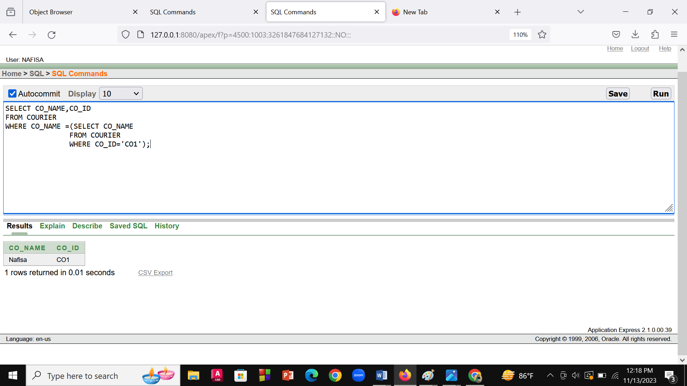

4.Select all the rows from the CUSTOMER table with the maximum id number.

SELECT *

FROM CUSTOMER

WHERE C_ID=(SELECT MAX(C_ID)

FROM CUSTOMER );

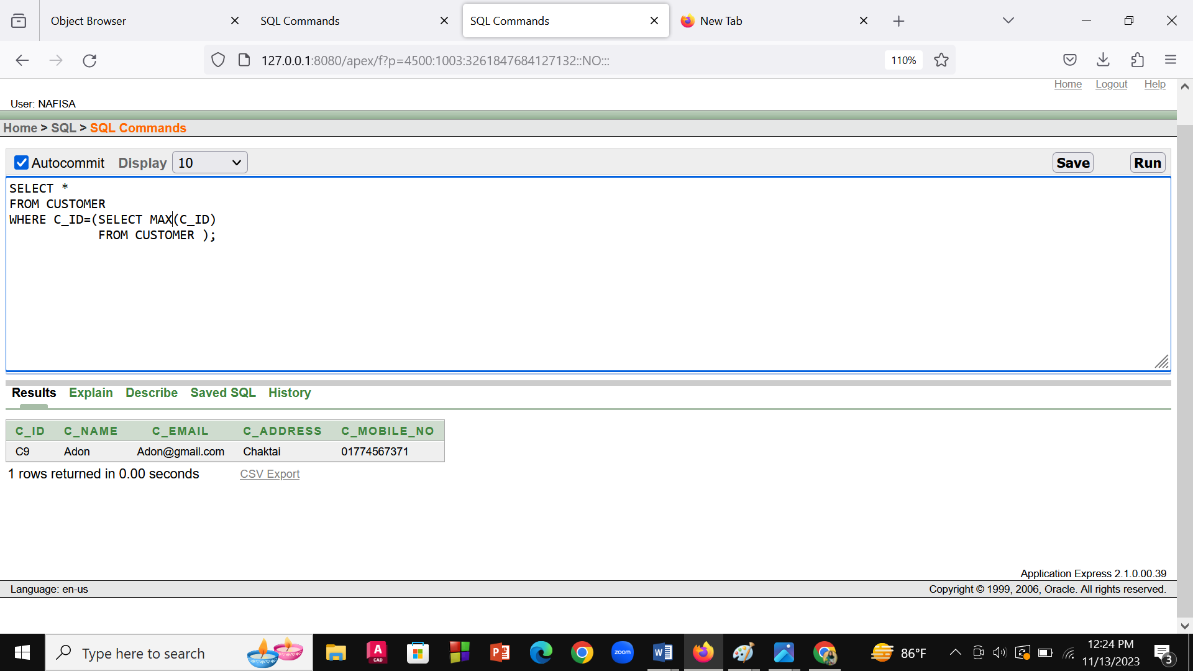

5. Show the delivery date with their courier names.

SELECT DELIVERY_DATE,CO_NAME

FROM PARCEL NATURAL JOIN (SELECT *

FROM COURIER)

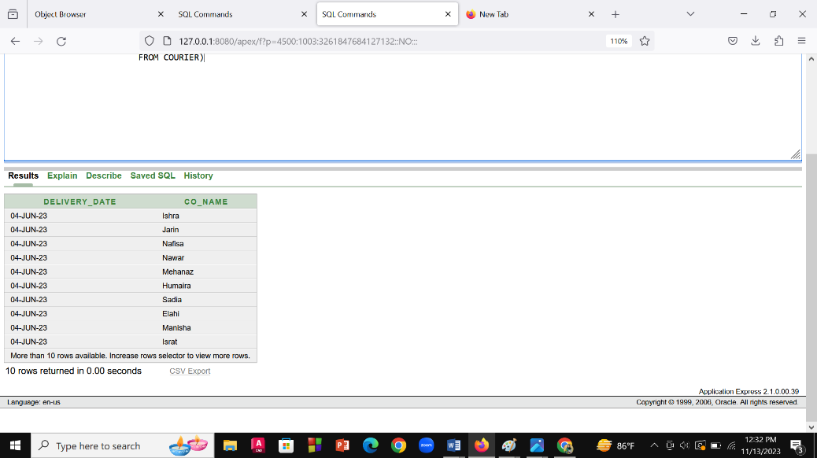

**PL/SQL**

1. FIND the total customer from the customer table using pl/sql

DECLARE n NUMBER;

BEGIN SELECT COUNT (*) INTO n FROM CUSTOMER;

dbms_output.put_line ('Total Customer:' ||n);

END;

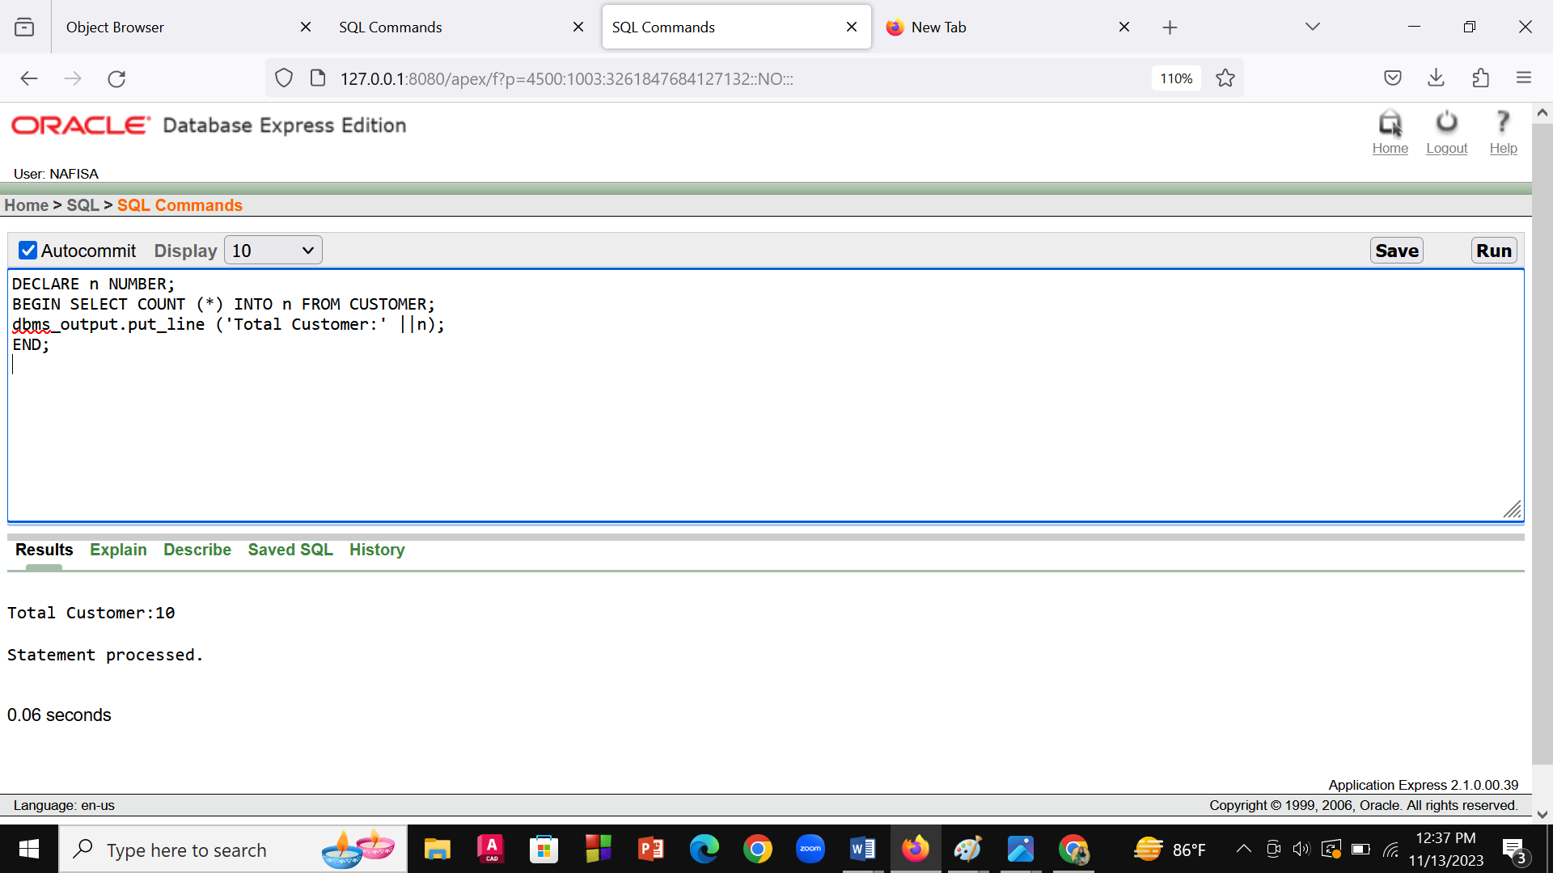

2.Show the details whose customer id is’C3’.

DECLARE

A CUSTOMER.C_ID%TYPE;

B CUSTOMER.C_NAME%TYPE;

C CUSTOMER.C_ADDRESS%TYPE;

BEGIN

SELECT C_ID,C_NAME,C_ADDRESS INTO A,B,C

FROM CUSTOMER

WHERE C_ID='C3';

DBMS_OUTPUT.PUT_LINE('CUSTOMER_DETAILS:');

DBMS_OUTPUT.PUT_LINE('CUSTOMER ID:'||A);

DBMS_OUTPUT.PUT_LINE('CUSTOMER NAME:'||B);

DBMS_OUTPUT.PUT_LINE('CUSTOMER ADDRESS:'||C);

END;

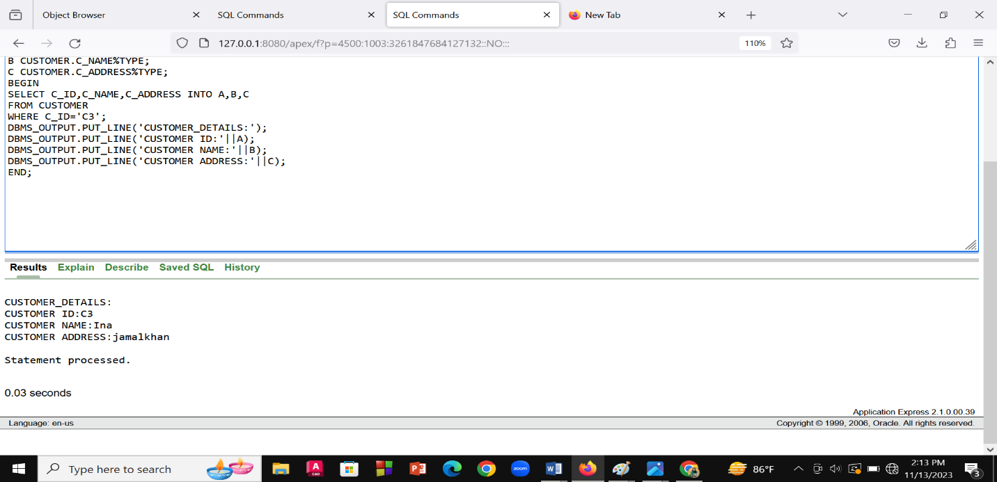

3.Show the id info of customer named ‘Jeba’.

DECLARE

A CUSTOMER.C_ID%TYPE;

B CUSTOMER.C_ADDRESS%TYPE;

BEGIN

SELECT C_ID,C_ADDRESS INTO A,B

FROM CUSTOMER

WHERE C_NAME='Jeba';

DBMS_OUTPUT.PUT_LINE('ID_NFO:');

DBMS_OUTPUT.PUT_LINE('CUSTOMER ID:'||A);

DBMS_OUTPUT.PUT_LINE('CUSTOMER ADDRESS:'||B);

END;

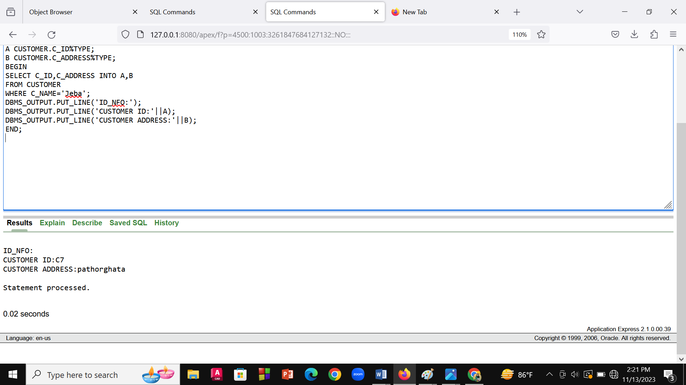

4.Show all customer names using cursor based record.

DECLARE

CURSOR s_cur IS

SELECT *

FROM CUSTOMER;

s_rec s_cur%rowtype;

BEGIN

open s_cur;

LOOP

FETCH s_cur INTO s_rec;

dbms_output.put_line('CUSTOMER NAME & CUSTOMER ADDRESS:

'||s_rec.C_NAME||' '||s_rec.C_ADDRESS);

EXIT WHEN s_cur%notfound;

END LOOP;

END;

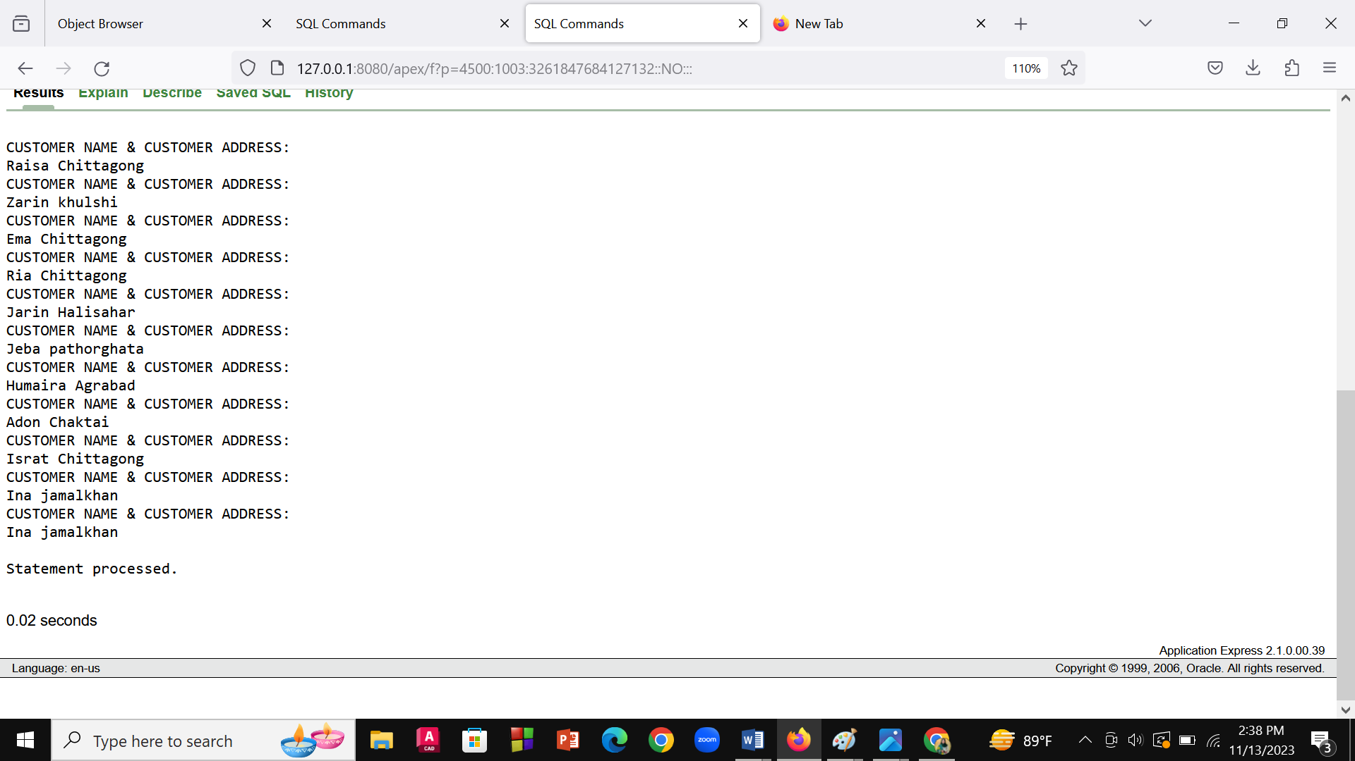

5.Show all admin nameusing cursor based record.

DECLARE

A ADMIN%rowtype;

cursor C IS

SELECT *

FROM ADMIN;

BEGIN

OPEN C;

dbms_output.put_line('ADMIN DETAILS:');

dbms_output.put_line('');

LOOP

FETCH C INTO A;

EXIT WHEN C%notfound;

dbms_output.put_line('ADMIN ID:'||A.A_ID);

dbms_output.put_line('A_NAME:'||A.A_NAME);

dbms_output.put_line('ADMIN ADDRESS'||A.ADDRESS);

dbms_output.put_line('');

END LOOP;

CLOSE C;

END;

